Project 1: Movie Recommendation System

Vivek Giri
MS in Data Science, Bellevue University
DSC680 – Applied Data Science
Professor - Amirfarrokh Iranitalab
December, 2025

Movie Recommendation System

Business Problem
Recommendation systems are information filtering tools designed to present users with the most relevant content. Tech giants like Netflix, Amazon, and YouTube rely on them to increase engagement and retention.
Video content platforms currently face a significant challenge of content overload. With vast libraries of data, users often struggle to find content that aligns with their specific tastes. The business requirement is for a system that can understand individual user preferences and suggest relevant movies to enhance user satisfaction and platform retention.

Background /history

Recommendation systems are critical information filtering tools used by tech giants like Netflix, Amazon, and YouTube to increase engagement. Traditionally, these systems evolved from simple popularity-based lists to complex personalized engines. This project examines the transition from elementary demographic filtering to more sophisticated hybrid systems that address challenges such as the "cold-start" problem.

Data Explanation
The system primarily utilizes datasets containing movie metadata and user interactions.

Data Dictionary:
- movie_id: A unique identifier for each movie.
- cast: Names of lead and supporting actors.
- crew: Names of directors, editors, and writers.
- genres: Categories like Action, Comedy, or Thriller.
- popularity: A numeric quantity specifying movie popularity.
- vote_average: Average ratings received by the movie.
- vote_count: The total number of votes received.
- userId: Anonymized user identifier (from MovieLens).
- rating: User-assigned score ranging from 0.5 to 5.0.

Methods
We propose a hybrid recommendation system that integrates three primary filtering methods:
- Demographic Filtering – Recommends popular content among similar demographic groups.
- Content-Based Filtering – Uses item metadata (genre, director, actors) to recommend similar movies.
- Collaborative Filtering – Finds users with similar tastes and recommends what they liked.

These methods, when combined, provide a personalized and scalable recommendation engine.

Dataset
MovieLens Dataset: https://grouplens.org/datasets/movielens/latest/
- 100,000+ ratings
- 3,000+ tag applications
- 9,000+ movies
- 600+ users (1995-2018)
The user data in the MovieLens dataset is anonymized.

System Design & Approach
1. Data Preprocessing:
- Cleaning nulls and duplicates
- Merging ratings with movie metadata
- Encoding genres
2. Content-Based Filtering:
- TF-IDF vectorization of movie descriptions
- Cosine similarity to find similar movies
3. Collaborative Filtering:
- Matrix factorization using Singular Value Decomposition (SVD)
- User-Item interaction matrix
4. Hybrid Model:
- Weighted ensemble of collaborative and content-based scores.

Analysis
The analysis involves processing movie credits to extract key features and evaluating model performance using metrics like Root Mean Square Error (RMSE). Preliminary findings suggest that while demographic filtering is simple to implement, hybrid systems provide superior accuracy by taking advantage of the complementary nature of content-based and collaborative approaches
To evaluate model performance, the following metrics will be used:
- RMSE (Root Mean Square Error): Measures error between actual and predicted ratings
- Precision@k: Measures the proportion of recommended items that are relevant
- Recall@k: Measures the proportion of relevant items recommended

Conclusion
A hybrid movie recommendation system can effectively enhance the user experience by providing more accurate and personalized suggestions than standalone methods. Leveraging both metadata and user behavior allows the system to remain robust even as data volume increases
Assumption
- It is assumed that historical user ratings accurately reflect future preferences.
- The data provided in the credits and movie datasets is assumed to be up-to-date and representative of a diverse user base.

Limitations
- Demographic Filtering: Too simple for practical use on its own, as it does not consider individual tastes.
- Content-Based Filtering: This can lead to a "filter bubble," where users are only recommended items that are very similar to what they have already seen.
Future Uses/Additional Applications
The hybrid methodology developed here can be extended beyond movies to other domains, such as e-commerce product recommendations or personalized news feeds

Recommendations
It is recommended to prioritize the development of the collaborative filtering component using advanced algorithms like Singular Value Decomposition (SVD) to better handle complex user patterns.

Implementation Plan
- Data Ingestion: Merge credits and movie datasets using unique identifiers.
- Feature Extraction: Parse stringified JSON data from columns like cast and crew.
- Model Training: Train demographic and collaborative models separately.
- Hybrid Integration: Combine model outputs to provide a single recommendation list

Ethical Assessment
Ethical considerations are central to the system's development. This includes ensuring user data is anonymized (userId) and monitoring the system for algorithmic bias that could unfairly promote certain content over others

Illustrations

Recommendation Systems are classified in mainly into three categories:
- Content-based systems
- Collaborative Filtering system
- Hybrid recommendation system.

Content-based systems work based on the label or genre of an item. If a user watched a movie, it recommends similar movies based on the director, genre, and many more aspects.

The main theory behind collaborative filtering is that if users ‘A’ and ‘B’ have rated similarly in the past, then there will be an assumption that they will rate similarly in the future

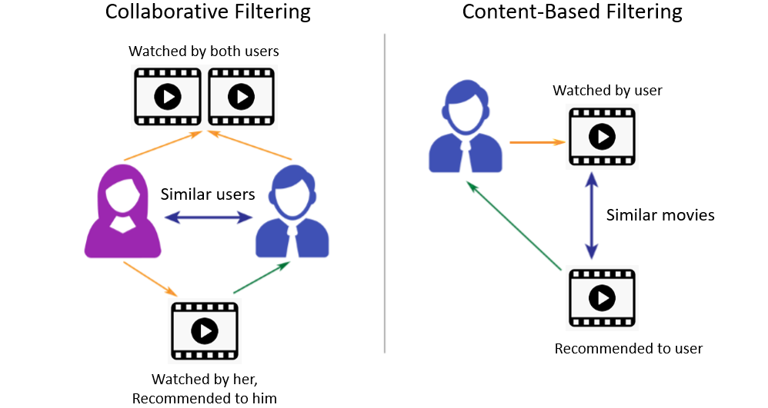

- Architecture diagram of a hybrid recommendation system

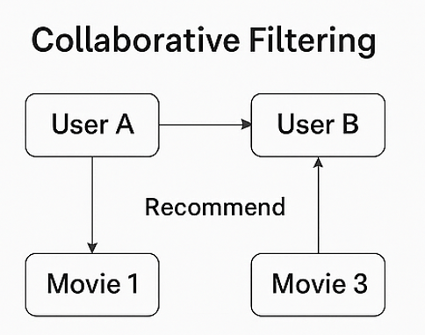

- Sample ratings matrix with user and movie IDs

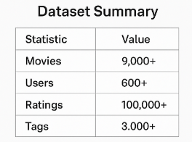

- Genre encoding example

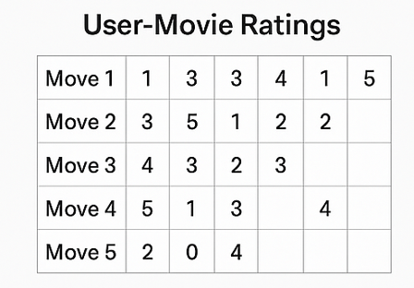

- RMSE score comparison of algorithms

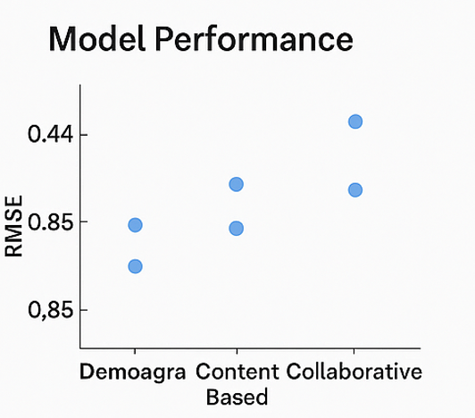

Appendix

- Data Sample:

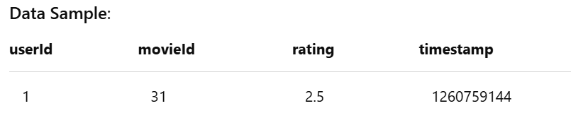
- Tools/Libraries: Python, Pandas, Scikit-learn, Surprise, Matplotlib

- Data Dictionary:
  - userId: anonymized ID
  - movieId: unique movie identifier
  - rating: user-assigned score (0.5-5.0)
  - timestamp: Unix time of rating

References

1. Great Learning. (n.d.). Masterclass on Movie Recommendation System. Retrieved April 2025, from https://www.mygreatlearning.com/blog/masterclass-on-movie-recommendation-system/
2. Koren, Y. (2008). Factorization meets the neighborhood: A multifaceted collaborative filtering model. Proceedings of the 14th ACM SIGKDD International Conference on Knowledge Discovery and Data Mining, 426–434. https://doi.org/10.1145/1401890.1401944
3. GroupLens. (n.d.). MovieLens latest datasets. Retrieved April 2025, from https://grouplens.org/datasets/movielens/latest/
4. NVIDIA. (n.d.). Recommendation system. Retrieved April 2025, from https://www.nvidia.com/en-us/glossary/recommendation-system/

